LAB PRACTICE ASSIGNMENT: 3

Title: DML Commands – INSERT, SELECT

Aim: To perform INSERT and SELECT operations using SQL.

Questions:
- Populate all the five tables with your own data.
- View all the records from the five tables.

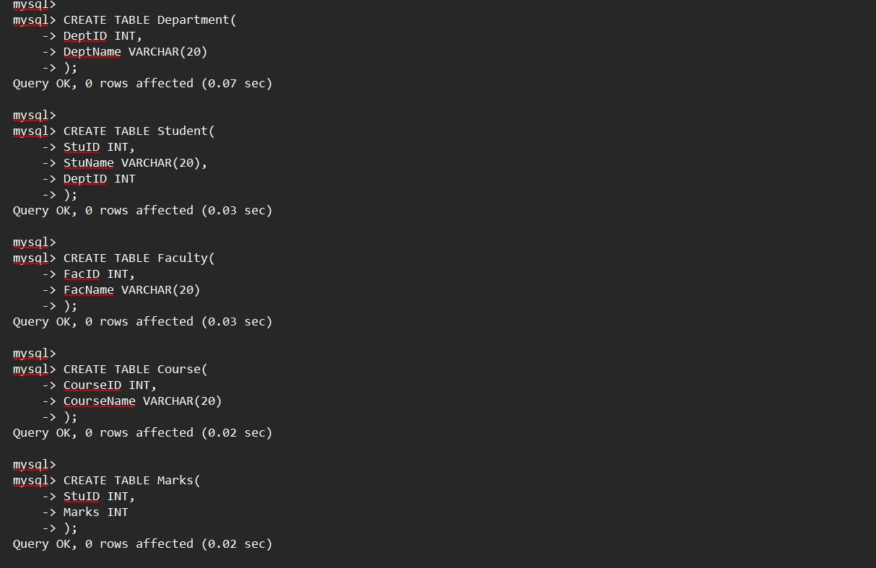
1- CREATE DATABASE StudentDB;

USE StudentDB;

